

***SKAPS INDUSTRIES INDIA PVT LTD.***

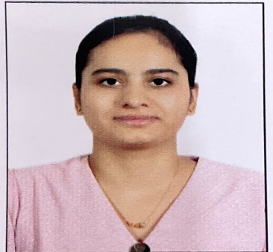

**INTRODUCING A NEW EMPLOYEE**

From: Human Resources  
  
**Re: Joining of Ms. Yashika K. Lal.**  
  
Date: 4th July 2023.  
  
Dear All,

I am pleased to introduce Ms. Yashika who has joined SKAPS Industries as a QA/QC Trainee in the PET-LAB department. She has done M. Tech in Molecular Engineering: Chemical Synthesis &Analysis from IIT Delhi.

Ms. Yashika will be deputed at Mundra Anjani plant and will be under training.

Please join me in extending a warm welcome to Yashika at SKAPS Industries and get acquainted with our SKAPS culture. We wish her success in the new opportunities and challenges ahead.  
  
  
Warm Regards,  
Human Resources.